Ready Reference  Management Centre Quick Start | RR6
Practice with the BCH Training Site

Use your existing BCH account to practice registering record on the BCH Training site.

Web address:

https://bchtraining.cbd.int/member/training-signin.aspx

Access the Management Centre

Web address:

https://bch.cbd.int/user/signin.shtml
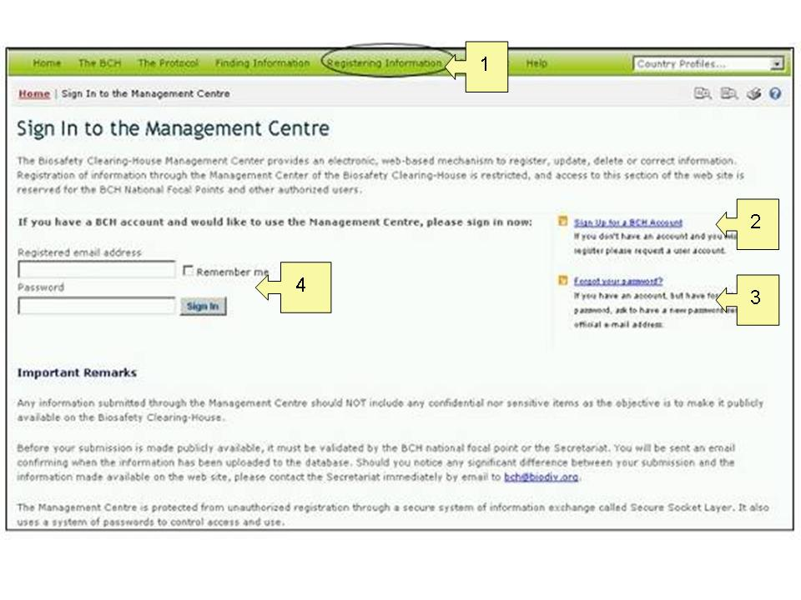
 | Open the Management Centre | Open the Management by following the link Registering information
 | Get a BCH account | Sign-up for a BCH account by filling in the online form.
 | Forgotten password | Re-set your password by following the instructions on the Management Centre home page.
 | Sign-in to your account | Enter your email address and password and click the “sign-in” button.

Navigating the Management Centre Home Page

Web address:

https://bch.cbd.int/managementcentre/

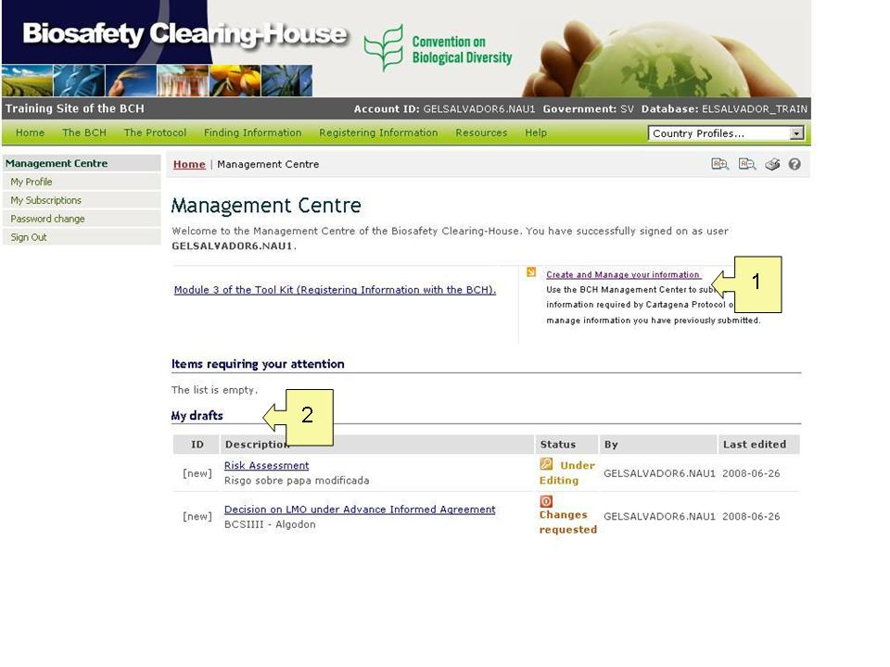

 | Create and manage your information | Use the BCH Management Center to submit information required by Cartagena Protocol or to manage information you have previously submitted  by following the link
 | Draft records | Access your draft records by clicking on the title of the record.
Creating new records; view or edit existing records

Web address: https://bch.cbd.int/managementcentre/myrecords.shtml

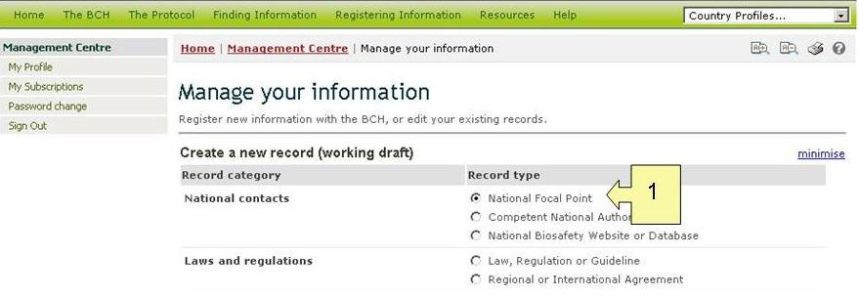
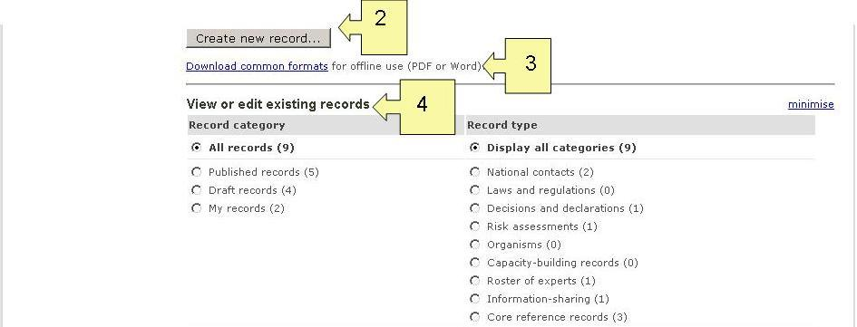
 | Choose a record | Choose a record from the list
 | Create a new BCH record | Click on the “create new record” button, then fill in the form and submit for publishing.
 | Get form for offline use | Download a copy of the common format for registering information to enter information off-line.
 | Existing records | View and edit your existing records.

